|  |  |
| --- | --- |
| **Seaboard Logistics Carrier Load and Pay Confirmation** | **2020-09-01** |
| ***Report Documentation*** |  |

# ****Purpose****

Send load and pay confirmation paper work for brokered loads.

# Security.

Depending on the end-users final specification, report may be automated.

# Data Population

The main data source will be our HDL TMW database.

|  |  |  |  |
| --- | --- | --- | --- |
| **Data Source** | **Object** | **Name** | **Description** |
| TMW | Table | dbo.Orderheader | Order Information |
|  | Table | dbo.Stops | Stop Information |
|  | Table | dbo.Freightdetail | Freight Information |
|  | Table | dbo.Carrier | Carrier Information |
|  | Table | dbo.City | Location Information |
|  | Table | dbo.Paydetail | Pay Information |
|  | Table | dbo.Company | Shipper and Consignee Information |

Stored Procedure: N/A

# Distribution Method Options

* SSRS report where order # can be entered to generate the confirmation. The generated report can then be printed and sent to the Carrier i.e. information is verified.
* Distribution is triggered by pay details being created for an order after it is completed.

# Report

## Template

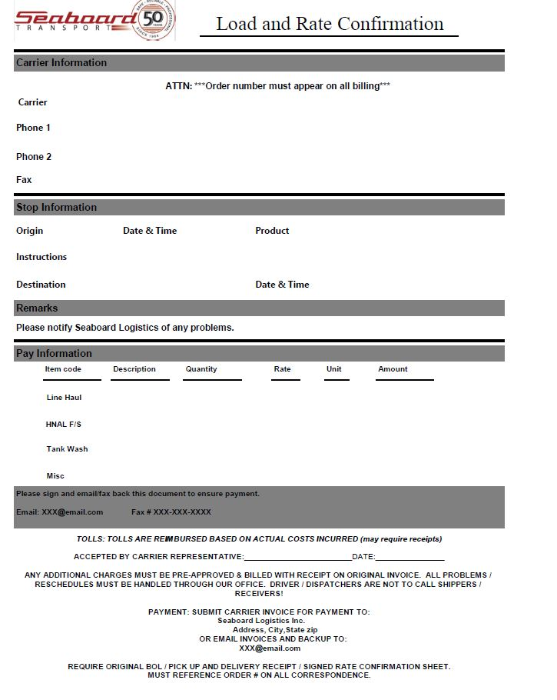

## Field Definitions

|  |  |  |
| --- | --- | --- |
| **Section** | **Description** | **Source** |
| Carrier Information | Carrier | Carrier information**(city,company & carrier tables)** |
|  | Phone 1 | Main Phone # **(Carrierprofile -> car_phone1)** |
|  | Phone 2 | Secondary Phone # **(Carrierprofile->car_phone2)** |
|  | Fax | Fax #**(Carrierprofile -> car_phone3)** |
|  |  |  |
| Stop Information | Origin | company id on LLD event**(stops-> cmp_id , stp_event = 'LLD')** |
|  | Date & Time | Stop arrival time of the LLD event **(stops-> stp_arrivaldatetime)** |
|  | Product | Freight commodity**(freightdetail->f.cmd_code)** |
|  | Instructions | Order remarks/notes **(orderheader -> ord_remarks)** |
|  | Destination | company id on LUL event**(stops-> cmp_id , stp_event = 'LUL')** |
|  | Date & Time | Stop arrival time of the LUL event **(stops-> stp_arrivaldatetime)** |
|  |  |  |
| Pay Information | Description | Pay description**(Paydetail-> pyd_description)** |
|  | Quantity | Paid Quantity**(Paydetail->pyd_quantity)** |
|  | Rate | Pay rate **(Paydetail->pyd_rate)** |
|  | Unit | Pay rate unit**(Paydetail->pyd_rateunit)** |
|  | Amount | Paid amount **(Paydetail->pyd_amount)** |

**CHANGE LOG**

|  |  |  |
| --- | --- | --- |
| Date | Edited By | Description |
| September 1st , 2020 | Momodou (Mo) Keita | Initial Creation of Document |